EXPERIMENT-17
17) Design and implement a water marking technique to insert the watermark into the original effectively image using Open CV.
a)CODE
import cv2
import os

img = cv2.imread(r"C:\Users\Varshini varshini\Desktop\photo.jpg")

if img is None:
print("Image not found!")
else:
watermark = img.copy()
cv2.putText(watermark, "WATERMARK", (30, 50),
cv2.FONT_HERSHEY_SIMPLEX, 1.5, (0, 0, 255), 3)

result = cv2.addWeighted(img, 0.7, watermark, 0.3, 0)

path = os.path.join(os.path.expanduser("~"), "Desktop",
"watermarked_image.jpg")
cv2.imwrite(path, result)

print("Watermarked image saved on Desktop!")
cv2.imshow("Watermarked Image", result)
cv2.waitKey(0)
cv2.destroyAllWindows()

b) INPUT
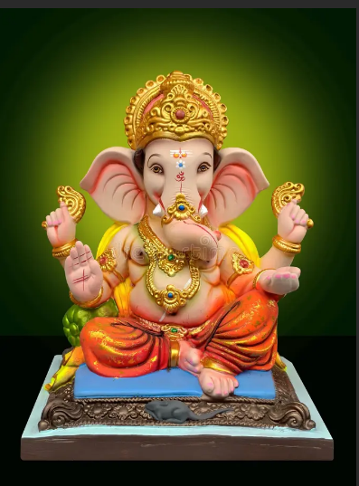

C) OUTPUT
